
VICKERSTOWN PRIMARY SCHOOL
SUMMER 2019 NEWSLETTER
Providing an outstanding education in the Heart of the Community
Welcome to the final issue of Vickerstown School Newsletter for this school year.
We have had a fantastic summer term; everyone has been working so hard! With lots of exciting activities already taken place and still lots more to look forward too! Please see our important dates column for upcoming events!
At the end of this term will we say a very sad farewell to Mrs Phizacklea, I’m sure you’ll all join us in wishing her all the best for the future. We look forward to welcoming Mr Holmes as the Headteacher from September.

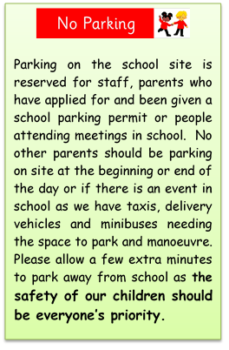
Become a School Governor
School Governors make a positive contribution to children’s education by offering supportive challenge to help raise standards and monitor resources effectively. They work as a team and come from a wide variety of backgrounds to add value to school life by offering their skills, expertise and time.
We are looking for dedicated individuals who want to make a difference in the lives of children and are willing to share their experience in an educational environment and who could also offer their knowledge and expertise in one or more of these areas; finance, human resources, health and safety, communications or managing premises.
If you have a passion for improving the life chances of children and can offer supportive challenge to the leadership of our school to help us to fulfil our vision, please contact the school office for further information.
Governors do not need any formal qualifications but must be aged 18 years and over.
Term dates 2019-2020
Autumn Term 2018 Wednesday 4th September – Friday 20th December
Half Term Monday 22nd – Friday 26th October
Spring Term 2019 Tuesday 8th January – Friday 29th March
Half Term Monday 16th – Friday 22nd February
Summer Term 2019 Monday 15th April – Friday 19th July
Half Term Monday 27th – Friday 31st May
Good Friday - 19th April Easter Monday - 22nd April
Early May Bank Holiday – Monday 6th May

Important Dates!

Yr 1 trip to Waterpark 3rd July
Y2 trip to Waterpark 4th July
Reception trip to Waterpark 9th July
Y2 Assembly 9th July
Race for Life 11th July
End of Term 19th July
Back to school 4th Sep



Last term we said a sad farewell to Mr Cooke after many happy years at Vickerstown.
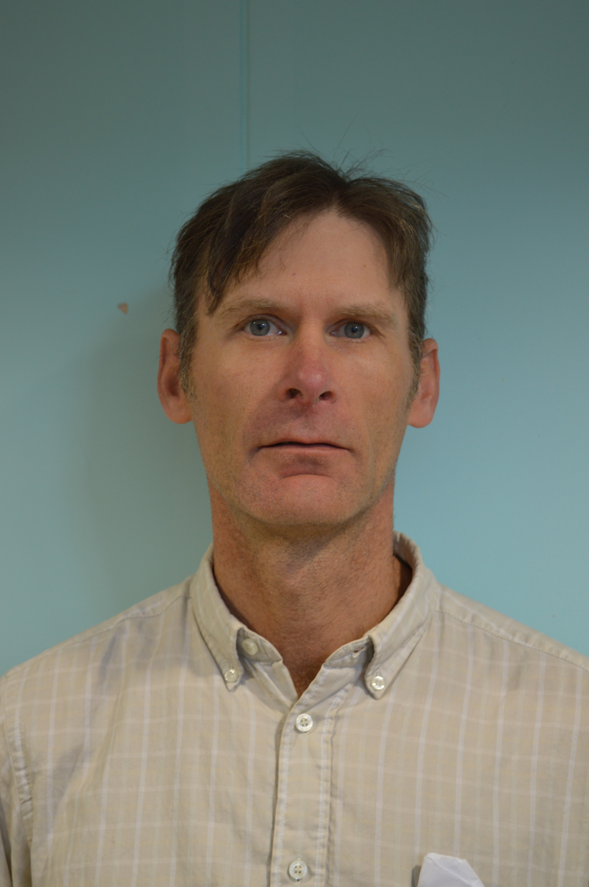
We wish him lots of luck for his future endeavours.

School have made a special donation to ‘Stacey’s Garden’ at Furness General Hospital. Stacey was a former student of Vickerstown Primary School and will be sadly missed.


A big thank you to the Cumberland Building Society for making a very kind donation to our ‘Out & About’ group to help cover the extra costs of transport.

A message from…
Friends of Vickerstown
Our big recent event has been the Coniston to Barrow walk. A big thank you to everyone who took part by walking, supporting and sponsoring our team. It was a brilliant day.
Next up we look forward to Vickersfest which is being organised by school and we will be helping to support. Thank you to Abi Dawes who puts a lot of work into this event, it was a great afternoon last year. Let’s hope for a lovely day for it!
It is events like these that allow us to support school in ways such as contributing to the minibus, SEN equipment and other school resources when they are needed. Last year we were able to replace a broken interactive screen in year 4. It also enables us to treat all of the children such as at Easter and school leavers. It is always nice to give Y6 a good send off as they move on to the next chapter!
We are always happy to hear your suggestions and we are always looking for people who would like to get involved with Friends. We meet on a very informal basis once or twice a term. If you cannot get to meetings but feel you could help occasionally at events such as Vickersfest or Christmas Fayre we would be very grateful. No one is asked to commit to any more than they are able to.
You can contact us by message to our facebook page or by email to Helen - wickismith@yahoo.co.uk or Susan - susanandeve@hotmail.com
Wishing you all a fantastic summer.


Vickers Fest
Friday 15th June
Another fantastic festival at Vickerstown, the children and staff really enjoyed it! Thank you to everyone who donated, ran a stall, helped out on the day and came to join us! Brilliant events like these wouldn’t be possible without your support!
We are pleased to confirm that a grand total of
£336
was raised!
Fantastic achievement!
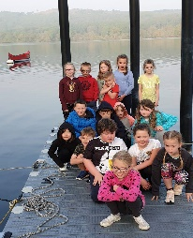
Gymnastics Competition
Mrs Charles & Mrs Foster held our annual gymnastics competition for all gym club members. Children showed their skills on the floor, vault and beam. All children did very well and enjoyed the day!
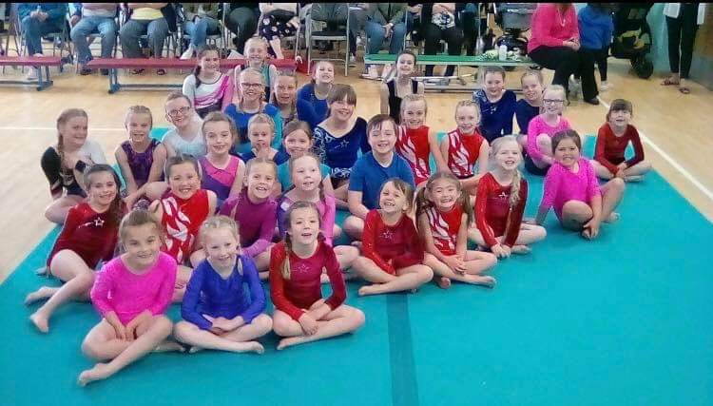


We will be holding our annual ‘Race for Life’ on Thursday 11th July.
This was a great event which the whole school took part in last year with help from parents, carers and other volunteers to marshal the course and walk with children.
More information will be sent out nearer the time, but if you are free on the day and would like to take part, help marshal or just cheer the children on along the way it would be greatly appreciated.

Y3 Trip to Tower Wood
Another fantastic trip, enjoyed by everyone!
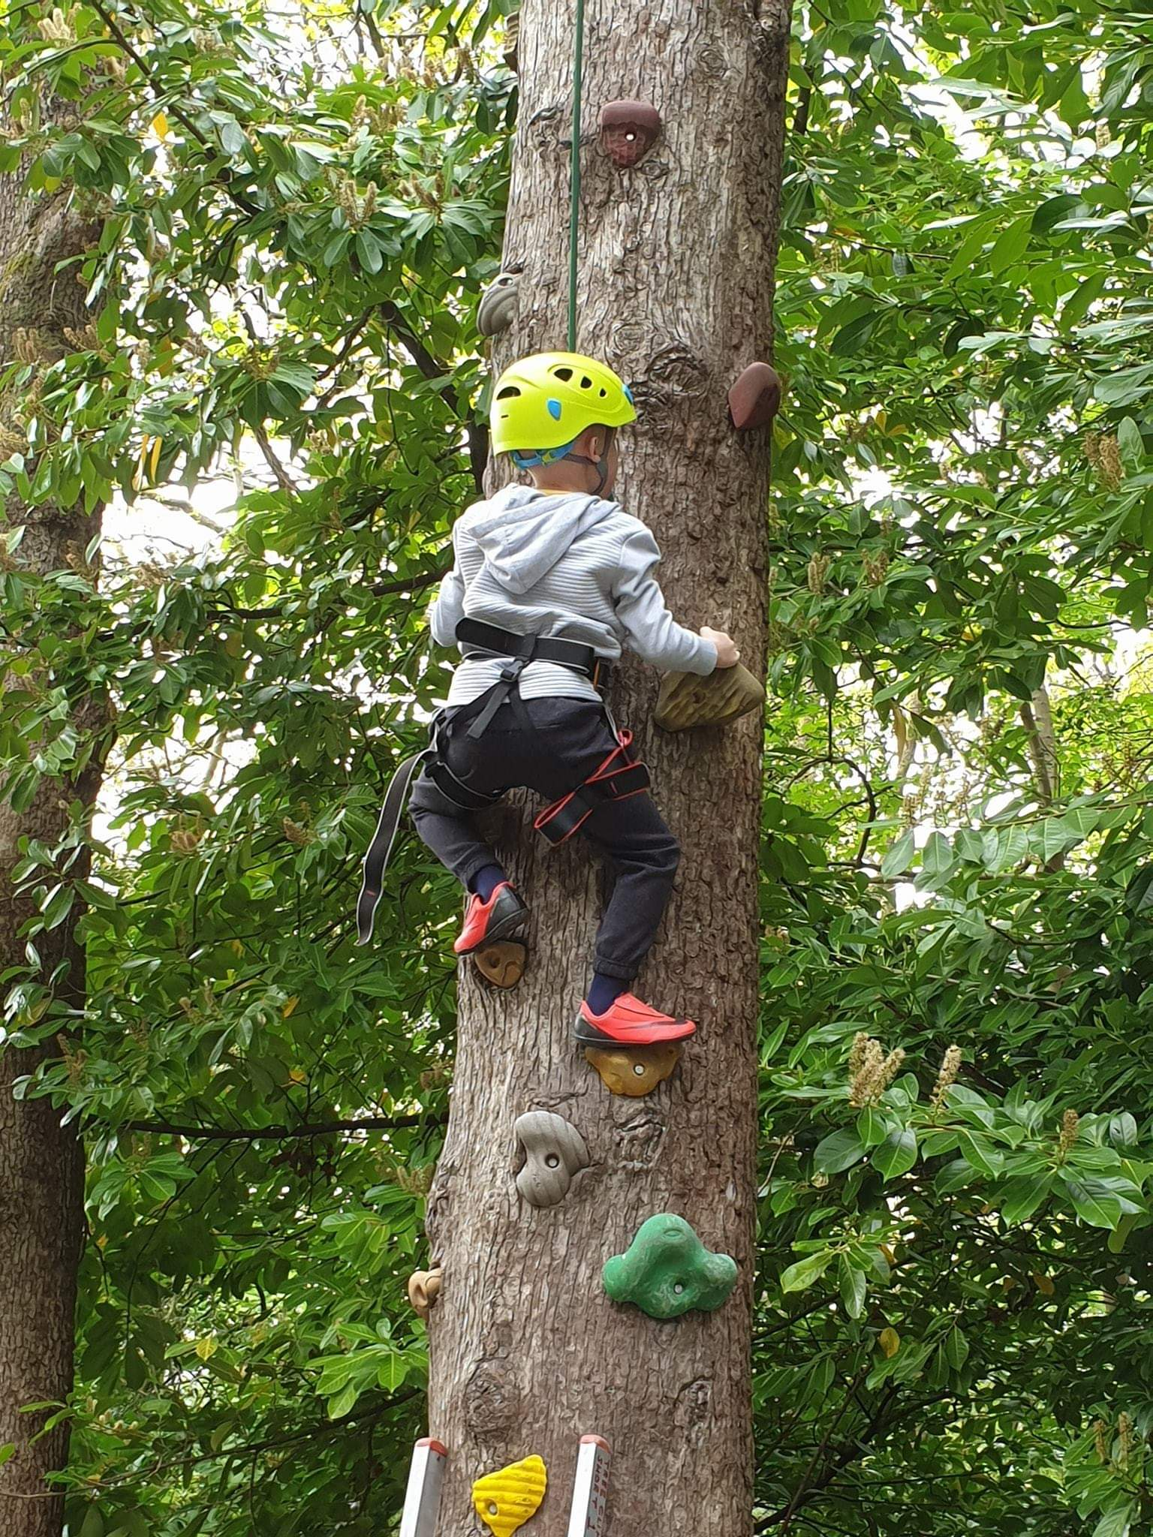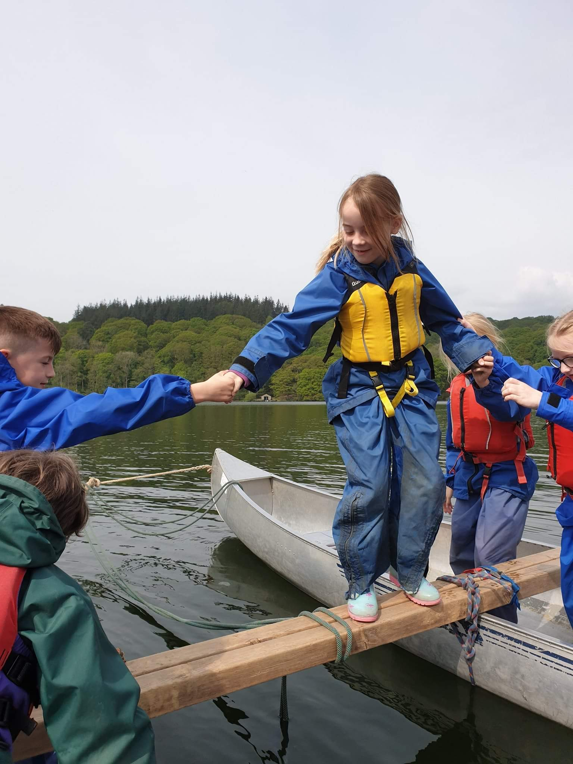
A huge WELL DONE & THANK YOU to everyone for your continued support this year!
Have a lovely break!



